COS80022 – Software Quality and Testing

Assignment 1 (D&HD)

Student Name: Arun Ragavendhar Arunachalam Palaniyappan
Student ID: 104837257
Student email: 104837257@student.swin.edu.au
Submission date: 14/04/2024

TASK A: Review of MyBank Functional Specifications document

The functional specification document of the MyBank Application was studied and analysed for an informal review. Initially, it seems to be a well written and detailed functional description, but on further in-depth analysis, the document leaves a lot of ambiguities, has a lot of typological and logical flow errors as well as many internal inconsistencies in system descriptions and functional descriptions within itself.

All of the issues that have been identified are discussed in depth in this informal review, with a main focus on the internal inconsistencies, but also covering other areas like ambiguity and missing elements, completeness, errors, feasibility and testability.

Ambiguities and missing elements:
- The term "business user" is used right from the beginning of the document, but is never clearly defined. It can possibly refer to the system analysts, software testers, customer service representatives, business executives, etc. A clarification is required on this, as, the application is only accessible to these “business users”.
- The Section 1.2 – Definitions, Acronyms and Abbreviations is empty and left unanswered. The terms ‘Business user’, ‘customer, ‘RCS’, ‘DVN’, ‘WVN’ and ‘ACN’ are blank and unknown.
- In Section3.2 of Customer maintenance, the layout has 2 address lines but only Address line#1 is mentioned in the form fields. Address line #2 is missing.
- The below snippet is highly ambiguous and creates confusion. There is no account type listing given above this text snippet. In fact, the account type listing comes much later, below in the functional specifications document.

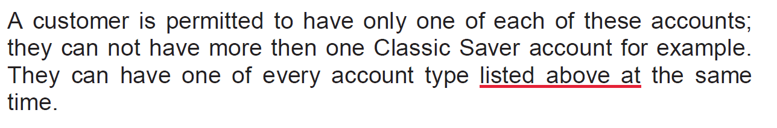

Inconsistency within Itself:
- Discrepancy in Withdraw Amount: The section 2.1 states that there is no limit on the amount a customer can ‘withdraw’. But, in section 3.5 of withdrawal description, it is mentioned that a user can withdraw any amount between A$10 and A$ 99999.99. This type of internal inconsistency is highly dangerous to the system’s functional design.
- Discrepancy in deposit amount: The ‘account maintenance’ section has a table that sets the minimum deposit amount for every type of account with the minimum amount being A500$. But in the ‘deposits section’, the minimum amount is mentioned at A$10.This is a clear discrepancy and there is no information in the document as well, regarding any explanation for this discrepancy.

- In Section 3.2, there is a huge discrepancy and confusion in the account type. The document lists down 4 account types, but provides 2 different and highly inconsistent definitions for the same within the same block.
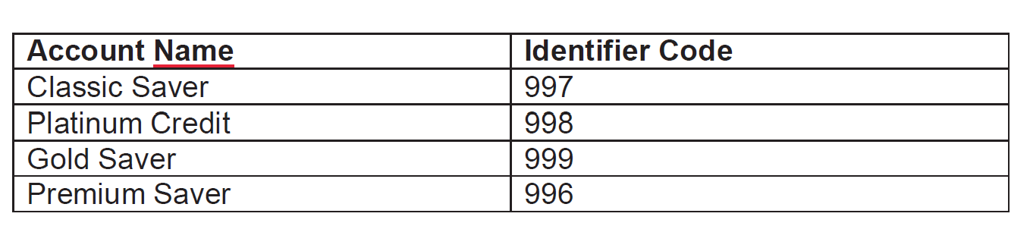
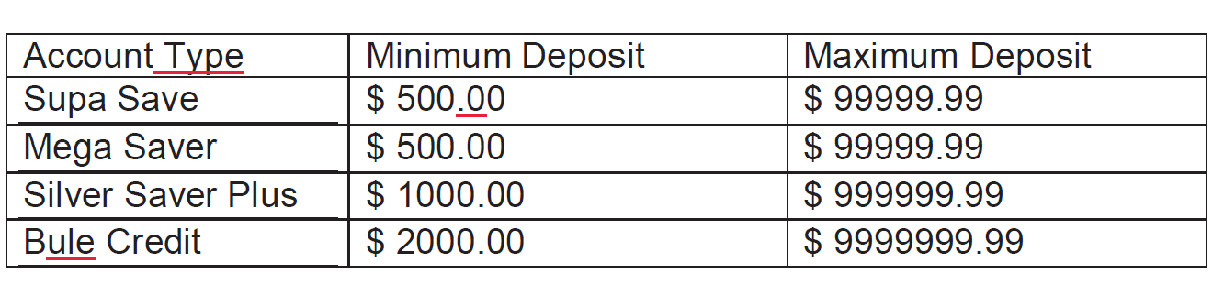
- The document mentions both of the above definitions for the account type.But, they are totally different and seem to have no linking or association of any kind to understand what the specification is trying to represent.
- Next, Section 3.3.3 mentions that the Account Maintenance section is only accessible from the Add customer or the Search screen. But , in section 3.3.5 program flow – mentions that the page can be called from Add customer ,Main menu , or the Search screen . This is confusing and inconsistent.

- In section 3.3.4 Button processing rules – The UPDATE and DELETE buttons have a press OK to complete the process and No to cancel the process, but the ADD button does not have this option, which is an internal functional inconsistency.
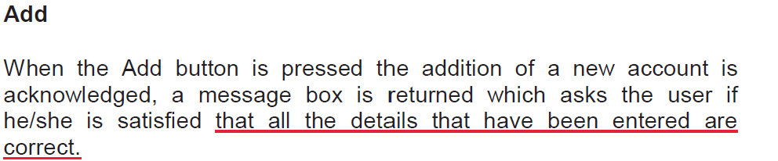
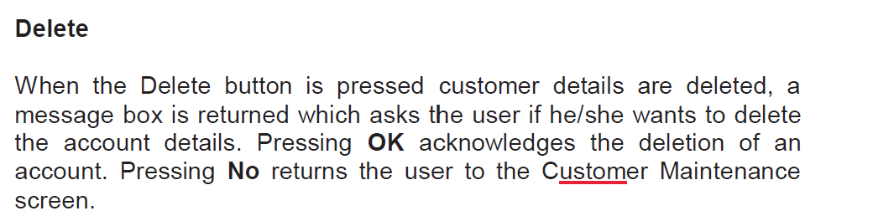

- In Account maintenence page , upon deleting an account the program flow returns to the corresponding customer maintenance screen of that account. Similarly , in an ideal case, upon deletion of a customer, the program flow should actually return to the main menu screen. But, in section 3.2.4 , upon deleting a customer , the flow is mentioned to return to the customer maintenance page which is incorrect and inconsistent.
- In section 3.5 , the Withdraw section GUI layout does not have an “ UPDATE” and “PRINT” button at all, in the first place. But there is an activity description for an “Update” and “PRINT button.This is highly incorrect and inconsistent even when compared to the Deposits sections which has a similar GUI layout.
- Also the “Transfer” option is just mentioned as ‘’other ” option, similar to how it is mentioned for the deposits section, this is not correct and inconsistent.
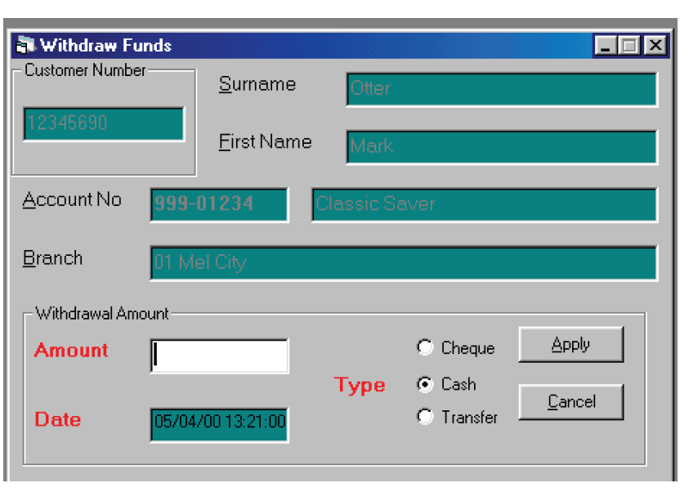
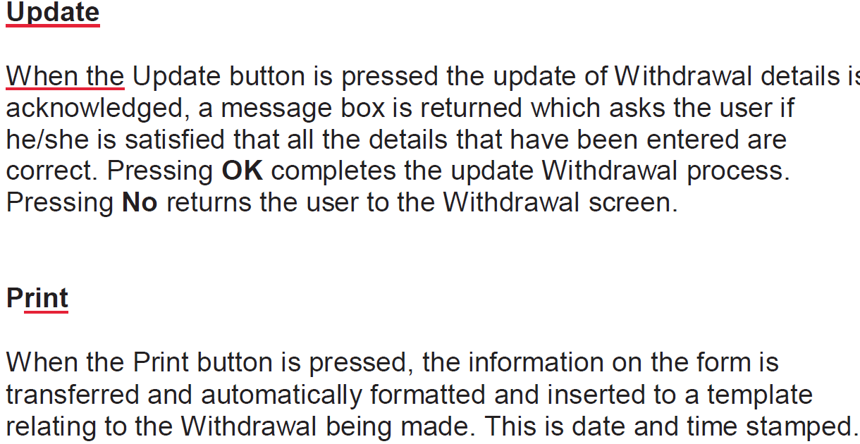

- Discrepancy in the form’s field format descriptions. Section 3.2 Customer Maintenance form does not have a format specification for the field inputs.

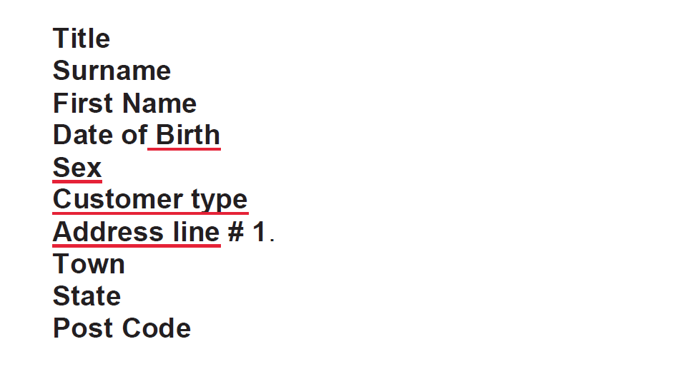
- But, the Section 4 Reports – has format specifiers for the input field.
- This is should have been consistently applied to all similar specifications in the document, but has not been done.
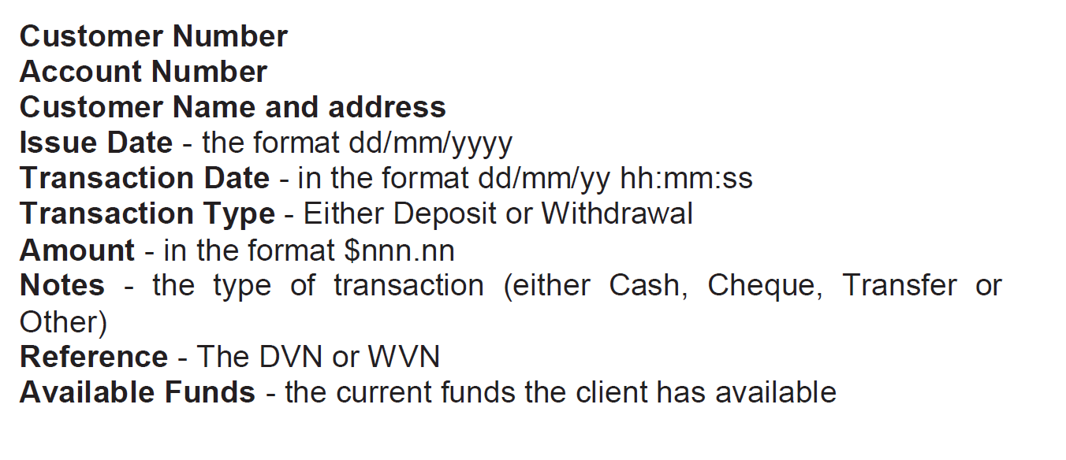

Lack of Completeness:
- The Section 1.1 mentions "Deferred Features" will be mentioned in the appendix. But in the appendix section, there is a only a small mention about the proposed full implementation of the security model of the system, but has no information about the functional details, implementation plans or the delivery timelines of this security model and hence is incomplete.
- The system overview diagram which is a crucial specification has an incomplete block.It should have ideally been filled as “ Deposit fund to an account – external/internal” in accordance to the data given in the functional requirements.This is a glaring miss.
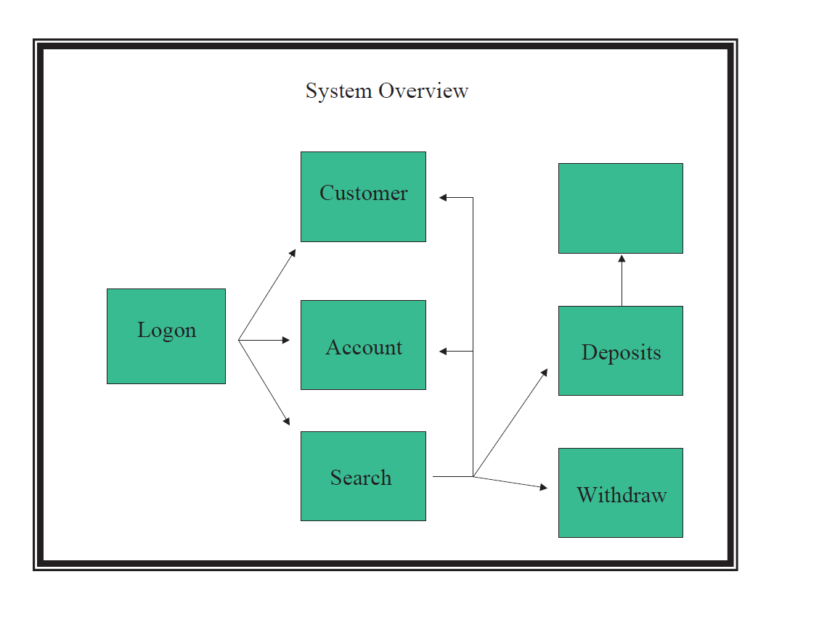
- The below snippet of the specifications from section3.2 is both incomplete in terms of specifications and also has typological errors.
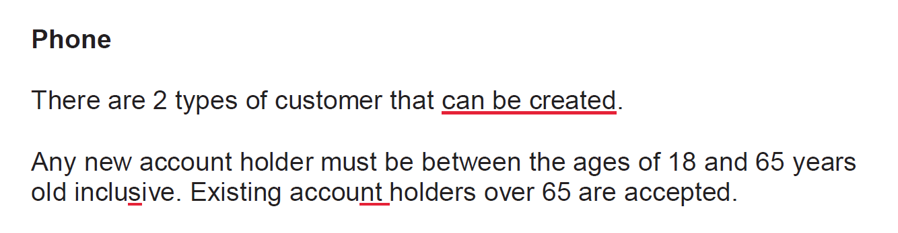
- Both the 3.4 Deposit and 3.5 Withdrawal sections have an “OTHER” payment option. This is highly incomplete. The section should have been more descriptive and specific as it is a direct transaction related function and can lead to a money related business impact or dependency. Hence, more definitive and concrete information is required on these sections about the “OTHER” payment option.
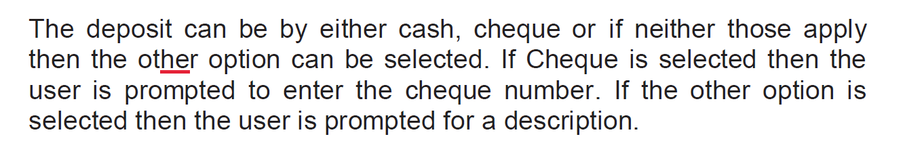
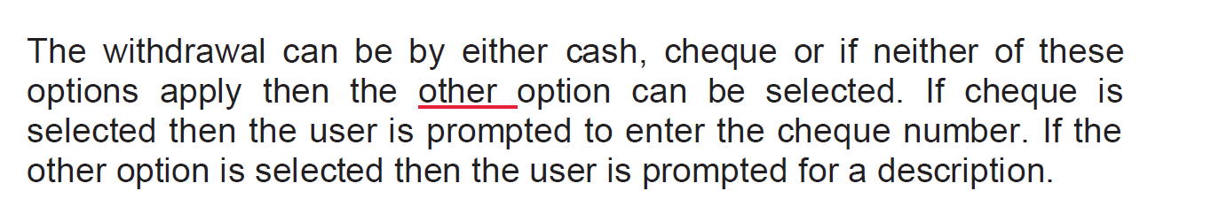
Errors:
- The initial functional requirements mention a ‘no limit’ on withdrawal or deposit which is not logically possible and is a clear error.
- There are a lot of grammatical errors throughout the document in a way that is significantly noticeable and at the same time causing a confusion on the exact information, which, that specific part of the documents is trying to provide.
- For example-missing punctuations, missing articles, incorrect usage of is/are, such as "he/she are satisfied" instead of "he/she is satisfied" or "they can not have more then one Classic Saver account" instead of "they cannot have more than one Classic Saver account." ,”Bule Credit” in account type instead of “Blue Credit” and “from the main menu, there all customer statements are produced” instead of “from the main menu, where all customer statements are produced” and many more such errors.

- The withdrawal section has a typological error, where there is an error in “a confirmation screen is displayed showing the amount deposited”, which should have actually been” a confirmation screen is displayed showing the amount withdrawn” as it is a withdrawal.
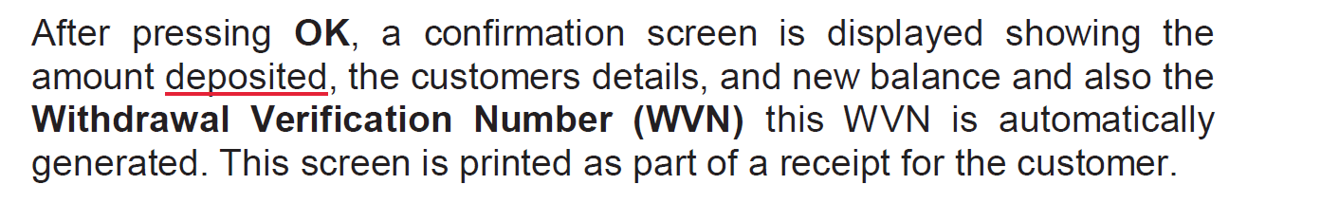

- The report print layout image is blurred and is not clearly visible for understanding and verification. A better image should have been presented which is clear and legible.

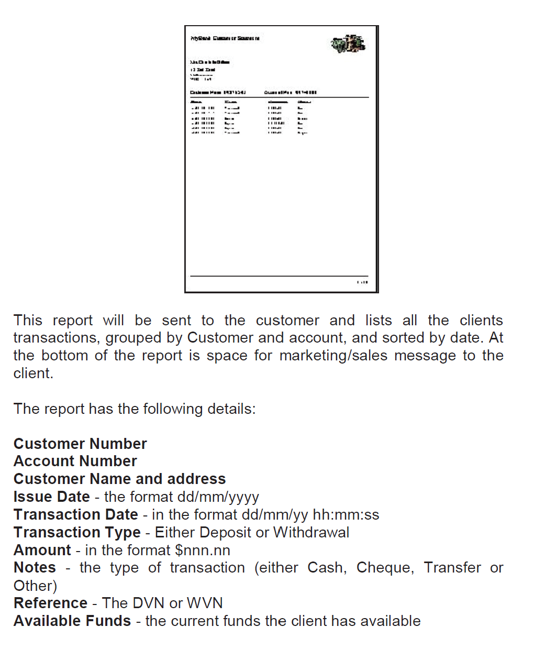

Feasibility issues:
- The document does not provide detailed information on the feasibility of implementing certain features, such as system performance under heavy load or scalability beyond the predicted volumes which are mentioned in the appendix in section 5 and 6.
- The training period of two days for staff members is highly optimistic, unrealistic and not feasible at all, as the given application system is a complex one with multiple inner branching and subdivision control flows, something which cannot be covered for full functional usage in just 2 days. It is ideal to have at least 2 weeks of training for the staff members who are going to get authorized to use this application.
- From a scalability point of view for the future, the report does have a table indicating current system usage volume and predicted future usage volume, but does not mention any details about how this information was obtained and what are the steps to be taken in the next version of the application to tackle such issues in the future.
- A detailed system load test report would have help to understand and explain this better, but that is clearly missing in this document.

Testability issues:
- The functional requirements outlined in the document seems to be testable, as they clearly defined the expected behaviour of the system for various actions of ADD , DELETE,UPDATE , OK , CANCEL operations and the error handling and alternative control flows are also described in the document.
- However, the document misses out on explicit mention of test cases that can test specific anomaly cases and boundary conditions, and they have not been included.
- Specific test case scenarios with verification methods like unit testing or user acceptance testing protocols could have been implemented for a more detailed functional specification report.

TASK B: State Machine Diagram for a Vending Machine System

States:
- Idle (S1): Idle is the first state. The vending machine waits for a customer to arrive and engage.
- Drink Selected (S2): The customer has chosen a drink.
- Card Inserted (S3): The customer has entered the card into the vending machine.
- PIN Entry (S4): The Vending Machine asks the customer to enter their PIN and customer enters the pin.
- PIN Verification (S5): The bank validates the PIN and payment.
- Payment Verification (S6): The Vending Machine confirms whether the payment is adequate for the selected drink.
- Drink Dispensed (S7): The Vending Machine dispenses the chosen drink. `
- Change returned (S8): The Vending Machine refunds any change if any due.
- Transaction Complete and return to idle (S9): The transaction is finished and the system returns back to idle state.
Transitions:
- Idle -> Drink Selected (T1): The customer choses a drink.
- Drink Selected -> Card Inserted (T2): Customer inputs their card to initiate a payment.
- Card Inserted -> PIN Entry (T3): Vending Machine prompts the user to enter their PIN.
- PIN Entry -> PIN Verification (T4): PIN information is now sent to the Bank for PIN and payment validation.
- PIN Verification -> Payment Verification (T5): The vending machine checks if the payment made is sufficient for the chosen drink.
- Payment Verification -> Drink dispensed (T6): if payment is sufficient, drink is dispensed.
- Dispensing a Drink -> Returning the Change (T7): After dispensing the drink, any change (if applicable) is returned.
- Returning Change -> Transaction is Complete (T8): After returning change (if applicable), transaction is complete and system returns to Idle.
- Any State -> Idle (Tc): The transaction can be cancelled at any point (the customer presses “CANCEL” button).

Guard Conditions:
- There are 2 possibilities on PIN Verification:
  - Valid PIN – Pin verified and next state transition happens
  - Invalid PIN – Transaction rejected; system returns to idle
- There are 2 possibilities on Payment Verification:
  - Sufficient Payment – payment is sufficient and next state transition happens
  - Insufficient Payment -> Transaction rejected; system returns to idle

- The ‘S’ notation represents the states.
- The ‘T’ notation represents the transitions.
- Both have been defined and referenced above in the textual description and are going to be represented in the below State Machine Diagram.

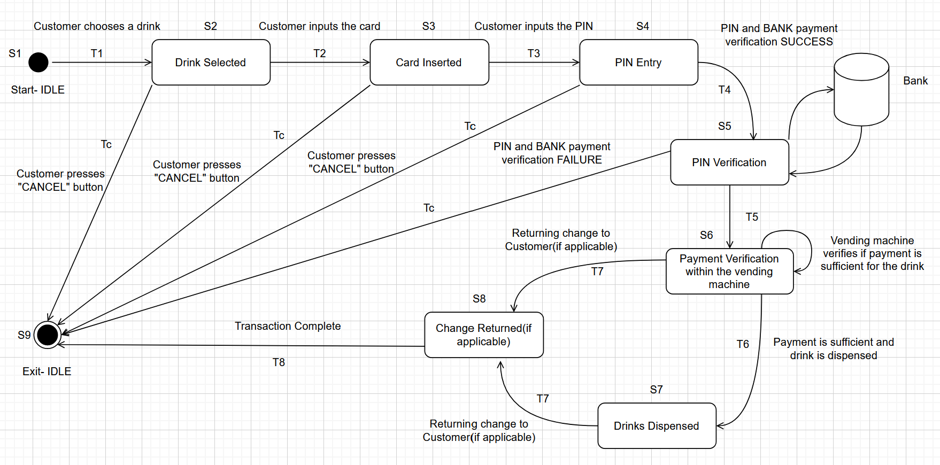
State Machine Diagram of the Vending Machine System

